Week 1

Lecture 1: Introduction, Modelling

Margaret Hamilton (programmer for Apollo 11, ICSE 2018): “When the computer crashed, sirens were loud… we had found a new way to debug, using sound.”

Understanding Systems
- Complexity:
  - A simple system interacts with its environment using IO messages
  - A complex system has multiple sub-systems and interactions
- Software system – a web of interconnected sub-systems, where each subsystem may or may not be divided into further subsystems
Abstraction
- One way of understanding complex systems to implement them
- Procedural abstraction
  - No need to have exact knowledge of computations
- Data abstraction
  - Groups together data on same entities
Object Oriented Design
- An object combines data and operations on that data
  - Data: class variables
  - Operations: methods
- Principles
  - Encapsulation
    - Combining data and operations in one entity
  - Inheritance
    - Classes can inherit from other classes (subclassing)
  - Polymorphism
    - “Many forms”
- Given a problem statement and requirements, carry out the following activities:
  - Identify objects
    - Objects that exist in the problem statement and requirements
    - Typically, select nouns, ignoring irrelevant ones (synonyms)
    - Look for relationships amongst the objects that were identified
      - Generalisation – relates to inheritance (subclass (specialisation) and immediate superclass) (“is a” hierarchy)
        - ex: animal and cat
      - Containment – 1 object contains another
      - Multiplicity – determines the quantity relationships between objects
        - ex: 1 animal with multiple legs
  - Identify operations
    - Typically, select verbs from the problem statement
    - Associate each operation with the object that is responsible for providing the behaviour
  - Create interfaces
    - An interface is created for each object that is to be represented by a class
      - The interface describes how the class can be used by specifying its public operations
    - An interface includes:
      - Return type
      - Purpose (description)
      - Pre- and post-conditions
  - Object interaction design
    - Describe how the objects communicate with each other via operations
    - and how the object, operations, and communications affect end users
Software Design
- Designing software is a symbiotic relationship between the end user and designer that requires the software designer to make the right design decisions, which reflect:
  - an intent on how the software is to function or be used
  - end users’ expectations as to how the software is compatible with contextual norms
- A balance of:
  - Modularity
  - Modifiability
  - Ease of use
  - Efficiency
  - Correctness
  - Maintainability
  - Understandability
  - Reusability
  - Portability
  - Fail-safeness
  - etc

Lecture 2.1: UML Diagrams

Software Design
- Design: specifying the structure of a software system and its functions (behaviour)
  - An opportunity to get insights on design alternatives to make appropriate design choice
  - Ability to evaluate the extent to which the system complies with end user expectations
- Design times (depends on situation):
  - Design while implementing code, then automatically design model representations
  - Design before implementations using an abstract modelling language (e.g., UML) (usually most appropriate)
  - Design after implementation (generate design automatically from the code)
- Software Design: a transition from what the system must do to how the system will do it
  - Typical questions:
    - What classes will be needed to implement a system that meets requirements?
    - What fields and methods will each class have?
    - How will the classes interact with each other?
  - The outcome of a software design activity is a domain model
Object-Oriented Analysis
- Domain Model
  - A conceptual model of the domain that incorporates both behaviour and data
    - A formal/semiformal/informal representation of a domain with concepts, roles, datatypes, individuals, and associated rules of interaction
UML (Unified Modelling Language)
- Diagrammatic representations of an OO systems
  - Programming languages are not abstract enough for OO design
  - UML is an open standard (used by many companies)
- Legal UML
  - A descriptive language: rigid formal syntax (like programming)
  - A prescriptive language: shaped by usage and convention
  - Okay to omit unnecessary things
- Notations:
  - 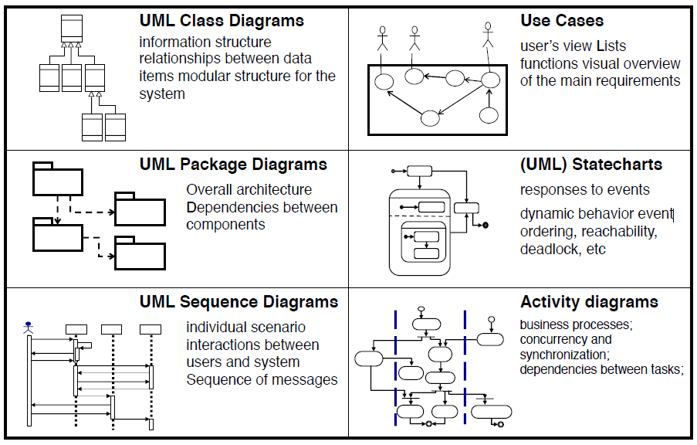

Lecture 2.2: Class Diagrams

UML Class diagram:
- A diagram of the classes in an OO system, their fields and methods, and connections between the classes that interact or inherit from each other
- Things not represented:
  - details of how the classes interact with each other
  - algorithmic details; how a particular behaviour is implemented
- Elements:
  - Class name in top of box
    - <<interface>> on top of interfaces’ names
    - italics for an abstract class name
  - Attributes (optional)
    - all fields of the object
    - Format: visibility name: type [count] = default_value
    - Visibility:
      - + public
      - # protected
      - - private
      - ~ package (default)
      - / derived
        - not stores, but can be compiled from other attribute values
    - underline static attributes
  - Operations / methods (optional)
    - may omit trivial (get/set) methods
      - don’t omit any in interfaces!
    - should not include inherited methods
    - Format: visibility name(parameters) : return_type
    - Visibility:
      - + public
      - # protected
      - - private
      - ~ package (default)
    - underline static methods
    - Parameter Format:
      - name: type
    - Omit return_type on constructors and when it’s void

Lecture 2.3: Relationships Between Classes

Relationships:
- Generalisation: an inheritance relationship
  - Types:
    - inheritance between classes
    - interface implementations
  - Hierarchies drawn top-down with arrows pointing upwards to parent
  - Line/arrow style indicates parent:
    - class: solid line, white arrow
    - interface: dashed line, white arrow
  - Omit trivial/obvious relationships (Object as a superclass for every class)
- Association: a usage relationship
  - 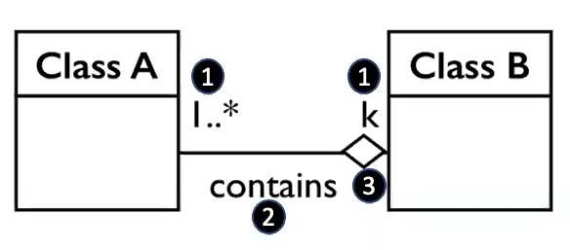
    - 1. Multiplicity (how many are used)
      - * (0+)
      - 1 (exactly 1)
      - 2..4 (between 2 and 4, inclusive)
      - 3..* (3+, * may be omitted)
    - 2. Name (what relationship the objects have)
    - 3. Navigability (direction)
  - Multiplicities:
    - One-to-One
    - One-to-Many
  - Types:
    - Aggregation: “is part of”
      - symbolised by a clear white diamond
      - ex: car, engine
    - Composition: “part can’t exist on its own”
      - stronger version of aggregation
      - the parts live and die with the whole
      - symbolised by a black diamond
      - ex: book, pages
    - Dependency: “uses temporarily”
      - symbolised by dotted line
      - often is an implementation detail, not an intrinsic part of the object’s state
      - ex: lottery machine, RNG
Tools for creating UML Diagrams:
- Violet – www.horstmann.com/violet
- ObjectAid UML Explorer (Eclipse plugin) – www.objectaid.com/class-diagram

Week 2

Lecture 3: Software Metrics

Why Software Metrics are important:
- When building software systems, we want to:
  - reduce complexity
    - Don’t add features at the end
  - increase modularity (and encapsulation)
    - Reduce interaction between different parts
  - increase maintainability
    - increase cohesion
      - Keep everything grouped
    - reduce coupling
      - Reduce interdependencies between modules
  - increase reusability
  - increase usability
- Motivation:
  - Estimate the cost & schedule of future projects
  - Evaluate the productivity impacts of new tools and techniques
  - Establish productivity trends over time
  - Improve software quality
  - Forecast future staffing needs
  - Anticipate and reduce future maintenance needs
Definitions:
- Measure – quantitative indication of extent, amount, dimension, capacity, or size of some attribute of a product or process
- Metric – quantitative measure of degree to which a system, component or process possesses a given attribute
- Indicator – combination of metrics that provide insight into the software process or project product itself
How can Quality be Measured?
- To define what can be used as a basis for measurement, Victor R. Bassili proposed a top-down goal-oriented framework for software metrics:
  - 1. Develop a set of Goals
  - 2. Develop a set of questions that characterise the goals
  - 3. Specify the Metric needed to answer the questions
  - 4. Develop Mechanisms for data Collection and Analysis
  - 5. Collect, Validate and Analyse the Data
  - 6. Analyse in a Post-Mortem Fashion (conforming to Goals)
  - 7. Provide Feedback to Stakeholders
- Types of metrics:
  - Process
  - Project
  - Product

Control Flow Graph (CFG)
- A representation, using graph notation, of all paths that might be traversed through a program during its execution
- Nodes are basic blocks in a program code
- Edges represent possible flow of control from the end of one block to the beginning of the other
- There may be multiple incoming/outgoing edges for each block
- How to draw:
  - 1. Identify methods in a class
  - 2. Divide the intermediate code of each method into basic blocks. A basic block is a piece of straight line code, i.e., there are no jumps in or out of the middle of a block
  - 3. Add labels (numbers for the nodes) to the following:
    - start of the method
    - each block
    - decision points (if, etc)
    - end of the method
  - 4. Generate a CFG of how to move from the first node to the last node (top to bottom)
    - An edge from one node to another exists if execution of the statement representing the first node can result in transfer of control to the other node
    - The graph is complete if there is a path from every other node to the last node
McCabe’s Cyclomatic Metric
- Given a CFG G, the cyclomatic complexity V(G) is
$$V\left(G\right)=E-N+2$$
  - N – number of nodes in G
  - E – number of edges in G
- For P graphs,
$$V\left(G\right)=E-N+2P$$
- Rule of thumb:
  - Begin restructuring code with the component with highest V(G)
  - 1-10: easy program, low risk
  - 11-20: complex program, tolerable risk
  - 21-50: complex program, high risk
  - >50: impossible to test, extremely high risk
- Advantages:
  - Easy to compute (parser)
  - Empirical studies: good correlation between V(G) and understandability
- Disadvantages
  - Only control flow (no data flow)
  - May be inappropriate for OO programs (where there are trivial functions)

CK Metrics
- In 1994, Shyam Chidamber and Chris Kemerer defined 6 simple metrics for OO programs
  - Since then, this work has been extended to over 300 metrics
- Objectives:
  - WMC (Weighted Methods per Class)
    - The sum of complexities of methods in a class
$$WMC=\sum_{i=1}^{n}{c_{i}}$$
    - c_i is the complexity of each method of the class
    - Complexity is the McCabe complexity of the method
    - Smaller values – better
    - WMC is a predictor of how much TIME and EFFORT is required to develop and maintain the class
    - Objective: low WMC
  - DIT (Depth of Inheritance Tree)
    - The length of the path from the node to the root of the tree
    - The greater the values,
      - the greater the number of methods (NOM) it is likely to inherit, making more COMPLEX to predict its behaviour
      - the greater the potential REUSE of inherited methods
      - small values of DIT in most of the system’s classes may be an indicator that designers are forsaking REUSABILITY for simplicity of UNDERSTANDING
      - Objective: appropriate trade-off
  - NOC (Number of Children)
    - For any class in the inheritance tree, NOC is the number of immediate children of the class (the number of direct subclasses)
    - NOC+:
      - REUSE+
      - the greater is the probability of improper abstraction of the parent class
      - the greater the requirements of method’s TESTING in that class
    - Small values of NOC may be an indicator of lack of communication between different class designers
    - Objective: appropriate trade-off
  - CBO (Coupling Between Object classes)
    - For a class C, the number of other classes to which the class is coupled
    - A class X is coupled to class C if:
      - X operates on (affects) C or
      - C operates on X
    - Small values of CBO:
      - improve MODULARITY and promote ENCAPSULATION
      - indicate independence in the class, improving REUSE
      - make easier to MAINTAIN and TEST a class
    - Objective: low CBO
  - RFC (Response For a Class)
    - The number of methods of the class plus the number of methods called by any of those methods
    - Normally, RFC is calculated up to the first method call level, not through the transitive closure of all method calls
    - RFC+:
      - Complexity+, debugging difficulties+
      - TESTING and MAINTENANCE becomes more COMPLEX
    - Objective: low RFC
  - LCOM (Lack of Cohesion of Methods)
    - Counts the sets of methods in a class that are not related through the sharing of some of the class’ fields
      - 1: Consider all pairs of a class’ methods
      - 2: Check if the pair share common fields
        - In some of these pairs both methods access at least 1 common field of the class, while in other pairs the two methods do not share any common field accesses
      - 3: LCOM: no. of method pairs that don’t share a field access minus no. of method pairs that do
    - A measure of the “tightness” of the code
    - LCOM+
      - Complexity+
      - Encapsulation- (implies classes should probably be split into 2+ subclasses)
    - Helps identify low-quality design
    - Objective: low LCOM
- 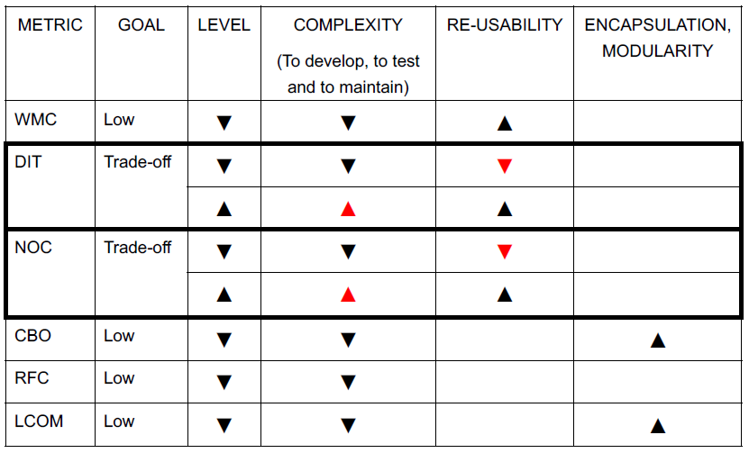

Lecture 4: Software Bugs

Software Reliability
- The probability of failure-free software operation for a specified period of time in a specified environment
- Denotes a product’s trustworthiness or dependability
- Due to bugs (not aging)
  - The more bugs, the lesser reliability
  - Failures seem random; hence, reliability theory can be applied
Bug Examples:
- Intel Pentium Floating-Point Division Bug
  - (4195835 / 3145727) * 3145727 – 4195835
  - Should be 0, but Intel Pentium CPU PCs get other results
- Windows calculator Standard vs Scientific Modes
What is a Bug?
- A software bug occurs when 1+ of the following rules is true:
  - The software doesn’t do something that the product specification says it should do
  - The software does something that the product specification says it shouldn’t do
  - The software does something that the product specification doesn’t mention
  - The software doesn’t do something that the product specification doesn’t mention but should
  - The software is difficult to understand, hard to use, slow, or, in the software tester’s eyes, will be viewed by the end user as just plain not right
- Def:
  - A common term used to describe a flaw, mistake, or failure in a computer system that produces an incorrect or unexpected result, or causes it to behave in unintended ways
Why do bugs occur?
- ~ 55% - Specification
  - Not written
  - Not complete
  - Not clear
  - Constantly changing
  - Not communicated well to the dev team
- ~25% - Design
  - Inappropriate modelling
  - Lack of modelling tools
  - Time to market pressure
  - Often, design is not considered important. Thus, inability to identify design bugs introduces as inappropriate consideration of design choices and the alternatives
- ~15% - Code
  - Software complexity
  - Poor documentation
  - Limited time
  - Programmer skills
- Other
Code Bug Examples:
- Apache Ant 1.6.2
- Eclipse 3.0.1
- J2SE version 1.5 build 63 (released)
Cost of Bugs:
- Most forms of testing find 1 out of 3 bugs. All tests together barely remove 58% of bugs
Bug repository
- Software users and devs report bugs to allow software devs to fix them
- Bugs are reported using bug reports, which are added to an issue tracking system or bug repository
Bug triaging:
- Assigning a bug to the most appropriate/capable dev who will fix it
- The bug triager reads, analyses, understands and assigns bug fixers for each newly reported bug
- Bug Triage
  - Prioritising bugs based on their seriousness and deciding what to do about each one
  - Fix what really needs to be fixed
- Challenges:
  - Knowledge about the system/project
  - Descriptiveness of bug report
  - Rate of reporting bugs
  - Many devs, different projects, various expertise
Bug Tracking Workflow
- A tester finds a bug and reports it
- The bug is assigned to a manager for initial triage
- The manager resolves it or assigns to a dev
- Resolved bug returned to tester
- The tester either closes the bug or reopen it with additional info or comments (go to 2.)
Goals of software testers:
- Find bugs as early in the software development processes as possible
- Make sure they get fixed
- Advice: Don’t get caught in the dangerous spiral of unattainable perfection
Robert Sabourin’s “I am a Bug”
- “You know you are finished when the only bugs left are the ones that you decide you can live with at least for now!”

Week 3

Lecture 5: Finding Bugs in Software (Static Analysis)

Debugging techniques:
- Threat Modelling – look at design, write out and/or diagram what could go wrong
- Manual code reviews and inspection
- Automated Tools (e.g., Static Analysis)
Bug Patterns
- Recurring correlations between signalled errors and underlying bugs in a program
- Common pitfalls of a programming language that are documented so that developers can learn to avoid them
- Eric Allen’s Bug Patterns in Java
- Examples:
  - Predictable RNG
    - Solution in Java: replace java.util.Random to java.security.SecureRandom
  - Using Object Deserialisation
    - Object deserialization of untrusted data can lead to remote code execution
    - Sensible operation that has a great history of vulnerabilities
    - Solution:
      - Avoid deserialising object provided by remote users
      - If that cannot be avoided, ensure that domain input validation is robustly applied for sanitisation
  - Trust Boundary Violation
    - A trust boundary can be thought of as a line drawn through a program
    - On one side, data is untrusted. On the other, data is assumed to be trustworthy
    - Validation logic allows data to safely cross the trust boundary (untrusted to trusted)
    - A trust boundary violation occurs when a program blurs the line
    - Solution for sessions:
      - Add validation prior to setting a new session attribute
      - When possible, prefer data from safe location rather than using direct user input
  - Null Pointer Exception
  - Infinite recursion
- Not all bugs are subtle and unique
  - Many bugs share common characteristics
- Bug pattern – code idiom that is usually a bug
  - Detection of many bug patterns can be automated using simple analysis techniques
- Categories
  - Correctness of the program
  - Not conforming to best practice (bad practice)
  - Internationalisation problems
  - Malicious code vulnerability
  - Multithreaded correctness
  - Performance
  - Security
  - Dodgy code
  - etc

Code Inspection
- Manually examine source code to look for bugs
- Limitations:
  - Labour-intensive
  - Subjective: source code might appear to be correct when it’s not
Debugger:
- Special program used to analyse other programs in order to find bugs
- Used to automatically detect bug patterns in program code
- Static:
  - Analyses statements, control flow, method calls, etc
- Advantages:
  - Can analyse many potential program behaviours
  - Doesn’t lose efficiency over time (humans getting bored)
  - Relatively objective
- Limitations:
  - Undecidable problem: In general, impossible to tell whether a program P has some property Q
    - Instead, approximate Q in analysis of P
  - The Halting Problem
    - Does program have bug X?
    - Can program P reach state X?
Correctness of code:
- Soundness
  - Bug detection system is sound if, whenever there is a bug in the program, an alert is raised
  - Unsound – can generate false negative outputs
- Precision
  - Every bug alert in the program is actually a bug
  - Imprecise – can generate false positive outputs
Program Analysis Trade-offs
- Generally, most program analysis are conservative (sound and imprecise)
- Detection of bugs in a program is an approximation that involves trade-offs between soundness, precision, and execution time
Balanced Approximation
- A static analysis to find bugs does not need to be consistent in its approximations
  - Neither sound nor complete: miss some real bugs and report some false warnings
- More flexibility to estimate likely program behaviours
Architecture of a Debugger (Java)
- Input:
  - set of .class files containing byte-code (more version-independent)
    - Frameworks:
      - Spring
      - AOP (AspectJ)
      - CGLIB (Byte Code Generation Library)
      - JavaAssist (Java Programming Assistant)
      - BCEL (Byte Code Engineering Library)
      - ASM
  - and/or set of .java files containing source code
    - Frameworks:
      - Eclipse JDT
      - Java Parser (AST generation and visitor support)
  - and/or configurations
- Processing
- Output:
  - Bug Pattern Code
  - Source Line Number
  - Descriptive Message

Lecture 6: Software Design

Design in general:
- The process of envisioning and planning the creation of objects, interactive systems, services, etc
  - User-centred, i.e., users are at the heart of the design thinking approach
  - About creating solutions for people, physical items, or abstract systems to address a need or a problem
Software design – the process of creating a specification of a software artifact, intended to accomplish goals, using a set of primitive components and subject to constraints
Software design viewpoints:
- “All the activity involved in conceptualising, framing, implementing, commissioning, and ultimately modifying complex systems”
- “The activity following requirements specification and before programming”
Design Concepts
- PHAME Principles:
  - Hierarchy
    - Provides the ability to break a system design into a taxonomical representation through the abstraction of packages and classes
      - Enables understanding of different aspects of the hierarchies
    - A subclass inherits state and behaviour in the form of variables and methods from its superclass and the rest of its ancestors
      - Top-to-bottom, the classes become more and more specialised
    - Ability to look at a problem space and sign a solution from the space by creating generalisation and Inheritance relationships between the different objects that define the problem space
  - Abstraction
    - The property for which only the essential details are displayed to the user
      - The trivial/non-essential units are not displayed
      - Ex: a car is viewed as a car rather than its individual components
    - Data Abstraction – the process of identifying only the required characteristics of an object ignoring the irrelevant details
  - Modularity
    - Liskov: ‘Modularisation consists of dividing a program into modules which can be compiled separately, but which have connections with other modules’
    - Grady Booch: ‘Modularity is the property of a system that has been de-composed into a set of cohesive and loosely coupled modules’
      - Strive to build modules that are cohesive (by grouping logically related abstractions)
      - Aim for loosely coupled software (by minimising the dependencies among modules)
  - Encapsulation
    - Involves bundling data and methods that work on that data within one unit, e.g., a class in Java
    - Provides explicit barriers among different abstractions and, thus, leads to a clear separation of concerns
    - Hides the internal representation, or state, of an object from the outside
      - AKA information hiding
    - Advantages:
      - Protects an object from unwanted access by client
      - Allows access to a level without revealing the complex details below that level
      - Reduces human errors
        - Simplifies the maintenance of the application
        - Makes app easier to understand

Week 4

Lecture 7, 8: SOLID, Design Patterns

SOLID Principles of Software Design
- Single responsibility
  - A class should have only 1 reason to change
- Open-closed
  - Ability to extend a class’ behaviour without modifying it
- Liskov substitution
  - Derived classes must be substitutable for their base classes
- Interface segregation
  - Make fine-grained interfaces that are client-specific
- Dependency inversion
  - Depend on abstractions, not on concrete implementations

Design Patterns
- Help designers apply best practices on how to realise software design principles
- Recurring design problems:
  - Most of the problems concern looking for optimal suitable arrangement of classes to provide a particular feature or ensure the system exhibits a required non-functional property
    - Optimal – ensures good quality design that eases maintenance and future evolution of the software
  - Can we add a new feature easily?
  - Can we change how part of the system is implemented without breaking the rest of the system?
  - Can we adapt the system with a new behaviour (i.e., at runtime) without having to rebuild everything else from scratch?
- Design patterns represent the best practices used by experienced object-oriented software developers to solve a problem
  - When a solution to a reoccurring design problem becomes well-established, i.e., it is an accepted solution amongst professional software engineers for that problem, it can be documented as a design pattern
- Gang of Four (GOF) proposed 23 foundational patterns, e.g.:
  - Creational patterns
    - Provide a way to create objects while hiding creation logic rather than instantiating objects directly using a new operator
      - Gives a program more flexibility in deciding which objects need to be created for a given use case
    - Ex:
      - Factory Method
        - Creates an instance of several derived classes
      - Abstract Factory
        - Creates an instance of several families of classes
      - Builder
        - Separates object construction from its representation
      - Prototype
        - A fully initialised instance to be copied/cloned
      - Singleton
        - A class of which only a single instance can exist
  - Structural Patterns
    - Describe how objects and classes can be combined to form larger structures
    - Types:
      - Class patterns
        - Describe abstraction with the help of inheritance and how it can be used to provide more useful program interface
      - Object patterns
        - Describe how objects can be associated and composed to form lager, more complex structures
    - Ex:
      - Adapter
        - Match interfaces of different classes
      - Bridge
        - Separates an object’s interface from its implementation
      - Composite
        - A tree structure of simple and composite objects
      - Decorator
        - Add responsibilities to objects dynamically
      - Façade
        - A single class that represents an entire subsystem
      - Flyweight
        - A fine-grained instance used for efficient sharing
      - Proxy
        - An object representing another object
  - Behavioural Patterns
    - Concerned with communication between objects
    - Ex:
      - Chain of Resp.
        - A way of passing a request between a chain of objects
      - Command
        - Encapsulate a command request as an object
      - Interpreter
        - A way to include language elements in a program
      - Iterator
        - Sequentially access the elements of a collection
      - Mediator
        - Defines simplified communication between classes
      - Memento
        - Capture and restore an object’s internal state
      - Observer
        - A way of notifying change to a number of classes
      - State
        - Alter an object’s behaviour when its state changes
      - Strategy
        - Encapsulates an algorithm inside a class
      - Template Method
        - Defer the exact steps of an algorithm to a subclass
      - Visitor
        - Defines a new operation to a class without change
  - Compound Patterns
    - Built from 2+ design patterns
    - Ex:
      - Model-View-Controller (MVC)
        - Combines Strategy, Observer and a Composite design pattern to supply the user interface, core logic, and data model for GUI-based apps
- Anti-patterns
  - Common recurrences of poor solutions to problems addressed by real design patterns
    - Repeatable ways of solving problems but in non-optimal and ineffective ways
  - Ex:
    - Inner platform effect
    - Excessive subtyping based on variable value partitioning
    - Database as messaging platform
    - Abstraction inversion
    - Magic push button
    - Object orgy
    - God object

State Design Pattern
- Behavioural
- Used when an object changes its behaviour based on its state
- State Machine
  - Writing code that’s based on a set of states and transitions
  - One Implementation:
    - Common way – a set of state constants
    - Transition – method
    - Problems:
      - Can result in not making sense and causing a lot of problems
      - Implementing too many closely related transitions can result in code duplication and developer fatigue
    - Assumption: new feature request
      - Three major code refactorings:
        - Create another state as a constant
        - Open up every existing method for the new state and add a new conditional for that state
        - Write 2 new transition methods
      - Conclusions:
        - Code is likely to get more complex with each additional feature request
        - Outcome is not OO
        - Any additions require many changes to code
        - Difficult to understand all states & transitions
        - Violates open-closed SE design principle
          - Any addition causes changing most of the code
- Alternative design – Each State as an Object
  - Implementation:
    - Take all states and convert into objects
    - Make all objects implement a common State interface
  - Advantages:
    - The interface has a method for each state transition
    - If we have a new state feature request, then all that’s necessary is to create a new class that implements the State interface. If there are new transitions, just add a new method across the classes
    - Not changing existing code
- 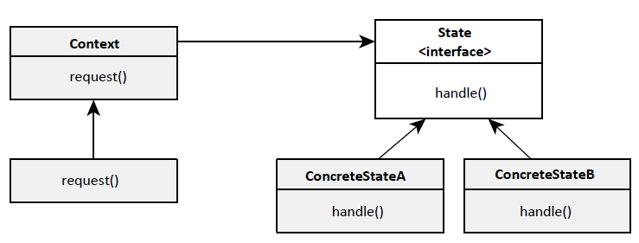
  - Context – class that manages all the various state
    - Delegates the request it receives to a state
- Key points:
  - Encapsulates state into separate classes
  - Context delegates to the current state to handle request
  - Once a request is handled, the current state may change
  - Each state has a different behaviour
  - Advantages:
    - Ability to encapsulate what varies
    - Favours composition over inheritance
    - Keeps a class closed for modifications but open for extension

Lecture 9: Composite Design Pattern

* - A structural design pattern that lets you compose objects into tree structures and then work with these structures as if they were individual objects

App needs to manipulate a hierarchical collection of ‘primitive’ and ‘composite’ objects
- Processing of a primitive object is handled differently than that of a composite object
- Querying “type” of each object before processing – not desirable
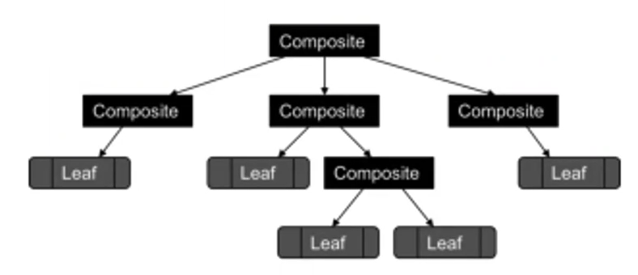
Ex: File System
- Entry is either:
  - text file, which holds a sequence of chars
  - binary file – sequence of ints
  - shortcut – handle or pathname to an Entry
  - folder – sequence of 0+ Entries
- Start folder (root /)
- Derive Leaf and Composite nodes from the same abstract base class
Structure:
- Component
  - Declare the interface for objects in the composition
  - Implements default behaviour
  - Declares methods for accessing and managing its child components
  - Optionally, can define methods for accessing a component’s parent in the recursive structure
  - Types:
    - Leaf
      - represents leaf objects in the composition
      - defines behaviour for primitive object
    - Composite
      - defines behaviour for components having children
      - stores child components
      - implements child-related operations in the component interface
- Client:
  - manipulates objects in the composition through the Component interface
- Consequences:
  - Defines class hierarchies consisting of primitive objects and composite objects
  - Makes client simple
  - Makes it easier to add new kinds of components
  - -: Can make design overly general
Structural patterns are concerned with how classes and objects are composed to form larger structures
Composite design pattern facilitates to compose objects into tree structures to represent part-whole hierarchies
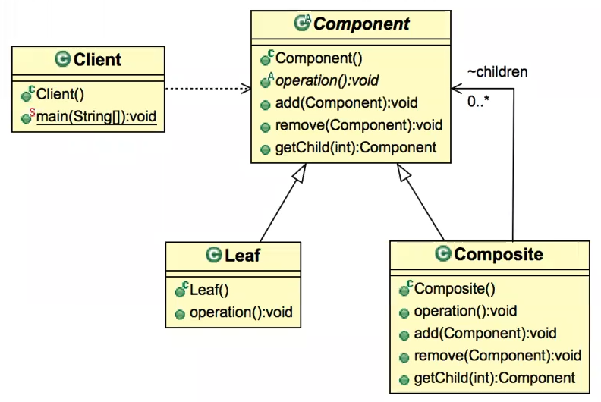
Abstractions are necessary in designing hierarchical composite structures, BUT each abstract type must eventually be resolved to a concrete type to do actual work

Tutorial 2: Liskov’s Substitution Principle

When creating class hierarchies, ensure that the new derived classes just extend without replacing the functionality of old classes
LSP states that if a program module is using a Base class, then the reference to the Base class can be replaced with a Derived class without affecting the functionality of the program module
Achieving LSP:
- Demand no more: The subclass should accept any arguments that the superclass would accept
- Promise no less: Any assumption that is valid when the superclass is used must be valid when the subclass is used
LSP – Design by Contract
- The contract of a method:
  - Precondition
    - A property that must be true before calling the method. If the precondition fails, the results are undefined
  - Postcondition
    - A property that is guaranteed to be true after the method. If the postcondition fails, it shall not return
  - Invariants
    - A property that is guaranteed not to change after executing the method

The LSP in terms of contract
- A derived class is substitutable of its base class if
  - its preconditions are not stronger (more) than the base class method
  - its postconditions are not weaker (fewer) than the base class method
  - the invariants remain the same
Rules
- When you override a method in a base class, the ???
- When you override a method in a base class, the postcondition of the overriding method should be stronger than the postcondition of the overridden method

Week 5

Lecture 10: Visitor Design Pattern

Composite Single-dispatch:
- The field AbstractFile a at compile-time can resolve to any of the concrete types at runtime
- At runtime, the program will dynamically dispatch to an object’s underlying type and call that object’s ls() method
- The actual operation getting executed depends on the name of the method being called and the type of the concrete component
- 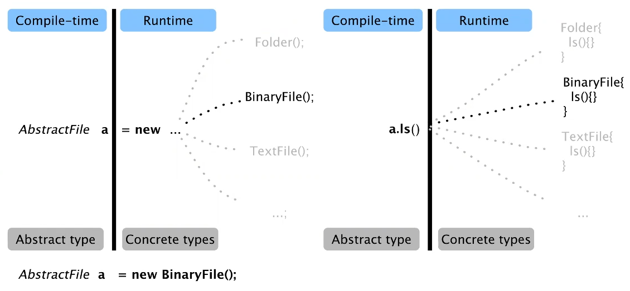

Problem: by simply adding every new operation to the AbstractFile interface and its concrete classes, too many are added in 1 place
Context:
- Assume you want to design operation(s) across a heterogeneous composition of objects
- You also want the operation(s) to be defined without changing the class of any of the objects in the collection because:
  - you want to avoid “polluting” the node classes with these operations
  - you don’t want to have to query the type of each node and cast the pointer to the correct type before performing the desired operation
Solution:
- Intent
  - Externalise and centralise operations on an object structure so that they can vary independently but still behave polymorphically
    - Static polymorphism – at compile time
    - Dynamic polymorphism – at runtime
- Approach:
  - Encapsulate a desired operation in a separate object – visitor
  - The visitor object then traverses the elements of the tree
  - When a tree node “accepts” the visitor, it invokes a method on the visitor that includes the node type as an argument
  - The visitor will then execute the operation for that node
- Implementation
  - Defining visitor
    - 1. Define ComponentVisitor base class
      - visit method
    - 2. Add accept operation to Component base class
    - 3. Define a concrete Leaf and Composite visitors as subclass of ComponentVisitor
    - 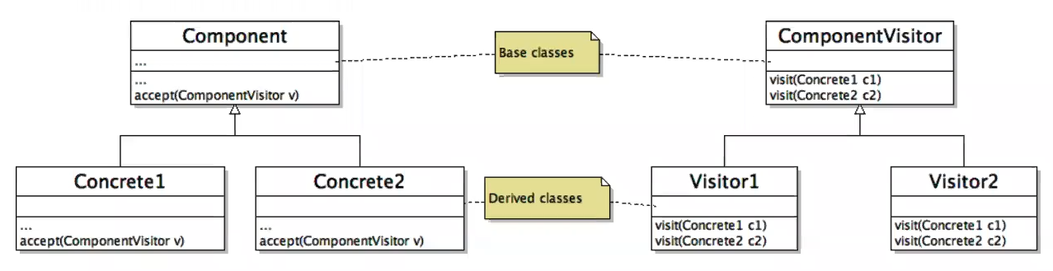
  - Semantics and structure for accept in all subclasses are the same
    - In all cases, accept is defined to receive 1 argument, which is a pointer or reference to the abstract base class of Visitor hierarchy
    - The Leaf/Composite uses accept to call visit in abstract base class and passes itself as argument
  - Client
    - When a client needs an operation to be performed on an object structure:
      - 1. It creates a ConcreteVisitor object
      - 2. Traverses the object structure
      - 3. Finally, it visits each element in the object structure using ConcreteVisitor
  - Traversing in:
    - Composite
      - Simplest solution
      - Only works if all the visitors need to visit the elements in the same order
    - Client (An External Class)
      - Client would require internal knowledge of data structure
      - Visitor remains generic
      - Traversal order
    - Visitor
      - Allows different traversal orders (for different visitors)
        - Allows each visitor to use a specific traversal
      - Useful for solutions that require complex traversals
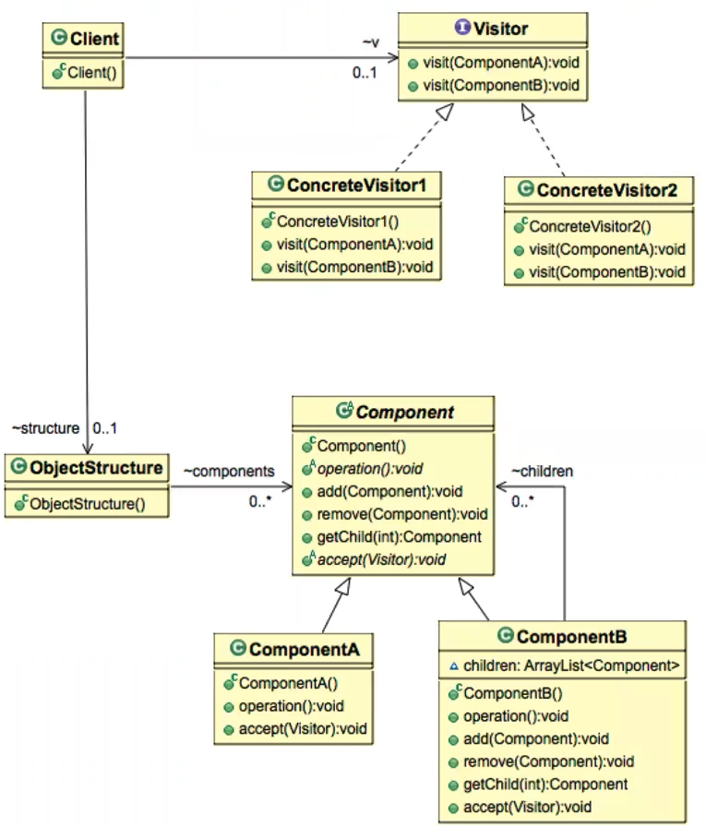
Visitor: Double-dispatch
- Assume you pass a parameter of type Visitor through the Component’s accept method
- Subsequently, you use a Client to call the accept method on a component instance
- Then, the actual operation getting executed depends on:
  - The type of the component (ComponentA/ComponentB)
  - The type of the visitor instance passed into accept (ConcreteVisitor1/ConcreteVisitor2)
Consequences:
- +: The hierarchy of the structure remains intact and unpolluted
- +: Consolidates and encapsulates functionality in Visitor object
- -: New concrete components may require changing the Visitor interface
- -: Circular dependency between Visitor and Component interfaces
Applicability
- When classes define many unrelated operations
- When class relationships of objects in the structure rarely change, but the operations on them change often
- When algorithms over the structure maintain state that’s updated during traversal

Lecture 11: VDP Case Study – Abstract Syntax Tree

Static Analysis
- * - Systematic examination of an abstraction of a program state space
  - Abstraction – no need to track everything
  - Systematic – check everything in the same way
Building a model of the Program
- Lexical analysis
- Parsing
- Abstract syntax
- Semantic Analysis
- Tracking control flow
- Tracking dataflow
- Taint propagation
Abstract Syntax Tree
- Intermediate program representation which depicts source code as a tree
  - Preserves program hierarchy
  - Node types defined by class hierarchy
  - Nodes can be associated with properties
  - Generated by parser
- Building in Java
  - Popular APIs for generating AST from source code:
    - Eclipse JDT (eclipse.org/jdt)
    - Java Parser (javaparse.org)
      - 1. Create a simple Maven project in Eclipse
      - 2. Add following dependency to POM.xml file
      - 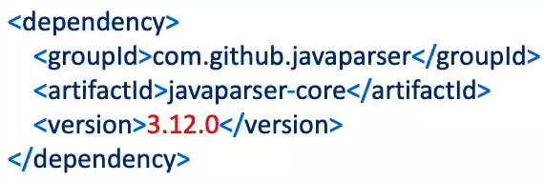
      - API:
        - JavaParser class is what produces the AST from the code
        - CompilationUnit is the root of the AST
        - Visitors are classes which are useful to find specific parts of the AST
- Notation
  - Triangle notation indicates that that part of the tree has been summarised
  - Root is CompilationUnit, representing the whole file
  - Nodes directly connected to the root are all the top elements of a file (i.e., package, import and class declaration)
  - From a single class declaration, multiple nodes, representing fields/methods of the class, can be reached
  - By zooming into MethodDeclaration, the name, return type and parameter(s) of the method are visible, along with a BlockStmt, which can also be zoomed in
- All Leaf nodes are Simple Names
- Each node is visitable
- Applying Visitor Design Pattern
  - Element code does not change when you need to change the behaviour
    - IElement, Element
  - Only Visitor code changed when you need to change the behaviour
    - IVisitor, Visitor
  - Base Interface classes – IElement, IVisitor
  - Derived concrete classes – Element, Visitor
  - Visitor Class
    - Architecture used when the aim is not to modify the underlying AST
    - 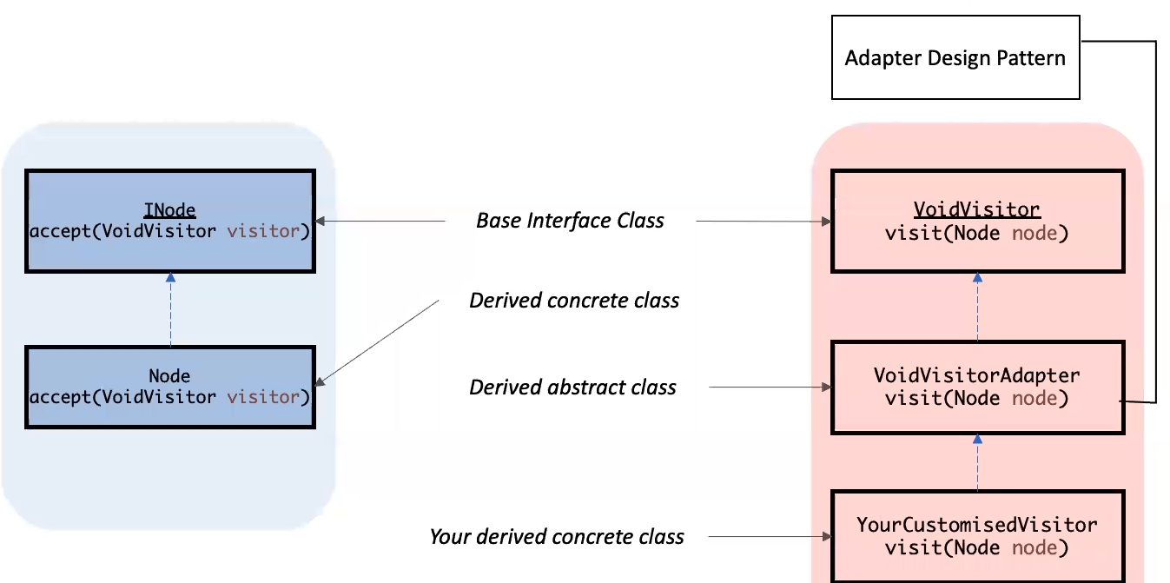
    - Advantage of adapter – when defining your own visitor, you only override the visit method for the type you are interested in
    - visit method takes 2 parameters
    - Transversal of the AST structure is executed via the Visitor
- AE2 ADVICE:
  - Think about maintaining state (giving it as a parameter)
  - To model attributes or not
[exercises as examples of implementations]

Week 7

Lecture 12: Strategy Design Pattern

Problem with Inheritance and Interfaces
- Inheritance is 1 of the core principles of OOP and design
  - One class inherits from the other if they share an is-a relationship (if a cat is a feline, then a cat class inherits from the feline class)
  - Easy to overuse inheritance – code becomes inflexible
    - Lose on reuse benefit of inheritance
    - Code duplication across classes
    - Hard to gain direct knowledge from the super class. Must navigate each subclass to learn what the code does
    - Simple changes to super class (like adding new feature) leads to unintended side effects on subclasses
    - All behaviour is assigned at compile time
- Interfaces
  - Allow different classes to share similarities
  - Allow for having 2 classes that are alike, but don’t have to have the same behaviour
  - Overusing
    - Destroys any possibility of code reuse
    - Tedious: Any change in behaviour would cause a maintenance nightmare, where all the subclasses with that behaviour need to be changed
    - Error prone: Does not allow for runtime changes in behaviours other than what the interfaces implement

Applying OOP principles
- “Identify the aspect of your app that vary and separate them from what stays the same”
  - Pull identified behaviours that change/vary out of superclass and create new classes for these behaviours
- “Program to an interface, not an implementation”
  - Use interfaces (supertype) to represent each behaviour
  - Use these interfaces to implement some concrete behaviours
  - Rework abstract superclass
  - Result: Rather than relying on an implementation of behaviour, it relies on an interface
Summary:
- Using composition for the behaviours that need more flexibility and inheritance for behaviours that won’t change
- By moving the algorithms out from the main inheritance hierarchy, the code allows to choose which algorithm each object gets
- If multiple objects need to use the same algorithm, code reuse is maintained
- The Strategy Pattern defines a family of algorithms, encapsulates each one, and makes them interchangeable
- Strategy lets the algorithm vary independently from clients that use it
HAS-A vs IS-A relationships
- IS-A – inheritance of state and behaviour
  - Inherits also unwanted behaviours (that must be overridden)
- HAS-A – gets behaviour by being composed with the right behaviour object
Summary of Summary
- The Strategy Pattern:
  - defines a family of algorithms
  - encapsulates each one
  - makes them interchangeable
- Strategy lets the algorithm vary independently from clients that use it

Lecture 13: Decorator & Observer DPs

Decorator Design Pattern

- Applies composition differently than Strategy
- * - attaches additional responsibilities to an object dynamically. Decorators provide a flexible alternative to subclassing for extending functionality

- 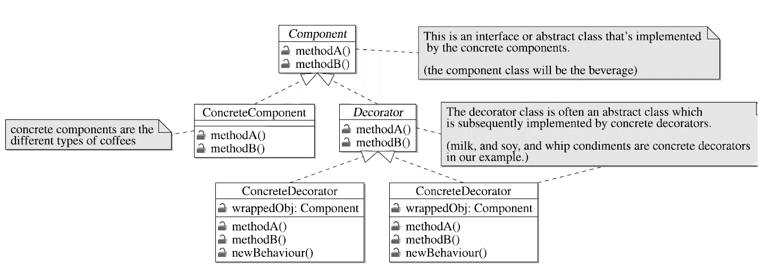
- 2 important parts:
  - Components (like beverages)
  - Decorators (like condiments for beverages)
- Concrete components and the decorators implement the same component superclass
  - Ability to wrap any decorator around any of the components
- Example in Java: java.io
  - FileInputStream class is a component that can be used to read data from a file
  - Can decorate this stream
    - With BufferedInputStream, which buffers input to improve performance
    - With LineNumberInputStream, which counts line numbers as it reads data
  - The call to read() is passed through the decoration layers to the main component, FileInputStream, with each decorator adding on its own functionality

Observer Design Pattern

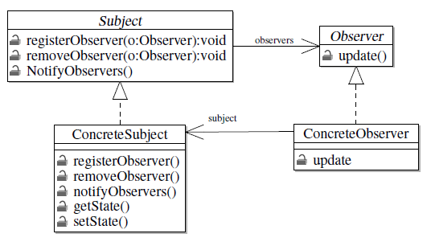
- Used for building event-driven software, e.g.:
  - Use input devices (like game controller)
  - IoT sensor devices that collect and report info on an event basis
  - Business rules, e.g., bank customer transferring 10,000+ pounds and a security device checking if that’s typical behaviour
  - Service provisioning process for a cloud server, e.g., milestones in a process can trigger events
  - Workflow management systems
- * - defines a one-to-many dependency between objects so that when one object changes state, all its dependents are notified and updates automatically
  - AKA Dependents, Publish-Subscribe, Model-View pattern
  - Motivation: The need to maintain consistency between related objects without making tightly coupled
- Subjects and Dependents/Observers
  - The Subject own’s the data
    - i.e., there’s only 1 copy of ‘data’, and the Subject is the sole owner
    - Thus, we end up with a design that’s cleaner than many objects owning the same data
  - The Dependents get notified when the subject ‘data’ changes
- Steps:
  - 1. Define the Subject interface
    - registerObserver()
    - removeObserver()
    - notifyObservers()
  - 2. Define the Observer interface to communicate with the Subject
    - update()
  - 2.5. Define the data communication protocol
    - Either:
      - Observer is sent a new value as part of the update call, or
      - Observer explicitly asks the Subject for the new value
  - 3. ConcreteSubject implements the notifyObservers method
    - notifyObservers is called any time data changes
    - notifyObservers calls the update method on each Observer
    - It’s common to implement getters and setters in Subject for data
  - 4. The concrete Observer is any class that implements the Observable interface
    - Implemented observable interface contains update(), which is called by the subject as necessary
- Java built-in support:
  - Observable class and Observer interface, in java.util
    - java.util.Observable – analogous to the subject interface, extendable
    - java.util.Observer – same as previous Observer interface
  - Data delivery:
    - Observers pull from the Subject
    - Subject pushes to Observers
  - 2 step process to notify observers
    - 1. Call setChanged(), which indicates that the state in the subject has changed
    - 2. Call notifyObservers()
      - for pull: notifyObservers()
      - for push: notifyObservers(Object arg)
        - arg contains updated data
  - Steps to receive notifications:
    - update(Observable o, Object arg)
      - o – subject (observable)
      - arg – object that encapsulates the changed data (only useful when pushing data to observers)
- Loose Coupling
  - Subjects and Observers are “loosely coupled” – they interact, but have little knowledge of each other
    - Subject only know that the observer implements a specific interface, and does not (need to) know concrete class/anything else
    - All the subject knows is that it has a list of objects that implement the observable interface
    - The observers can add, remove, or replace themselves from the list at anytime
  - If there’s a need to add new types of observers, modification of the subject is never needed
  - Observers just need to implement the Observer interface
  - No changes to the subject or observers will affect the other
- Summary:
  - Key:
    - Loose coupling is an important OO design principle
    - Loose coupling gives the flexibility to vary the design without breaking the contract between interacting objects
  - Disadvantage:
    - Can cause memory leaks, known as the lapsed listener problem

Week 8

Lecture 14: Software (Unit) Testing

Bugs
- Inevitable in any complex software system
- Industry estimates: 10-50 bugs per 1000 lines of code
- A bug can be visible or can hide in code until much later
- Quotes:
  - “Testing is the process of comparing the invisible to the ambiguous, so as to avoid the unthinkable happening to the anonymous” – James Bach
  - “Testing is organised scepticism” – James Bach
  - “Program testing can be used to show the presence of bugs, but never to show their absence!” – Edgar Dijkstra
Testing Definitions
- “Testing is the process of establishing confidence that a program or system does what it is supposed to”
- “Testing is the process of executing a program or system with the intent of finding errors”
- “Testing is any activity aimed at evaluating an attribute or capability of a program or system and determining tat it meets its required results”
- A systematic attempt to reveal errors
  - Failed test: an error was demonstrated
  - Passed test: no error was found (for this situation)
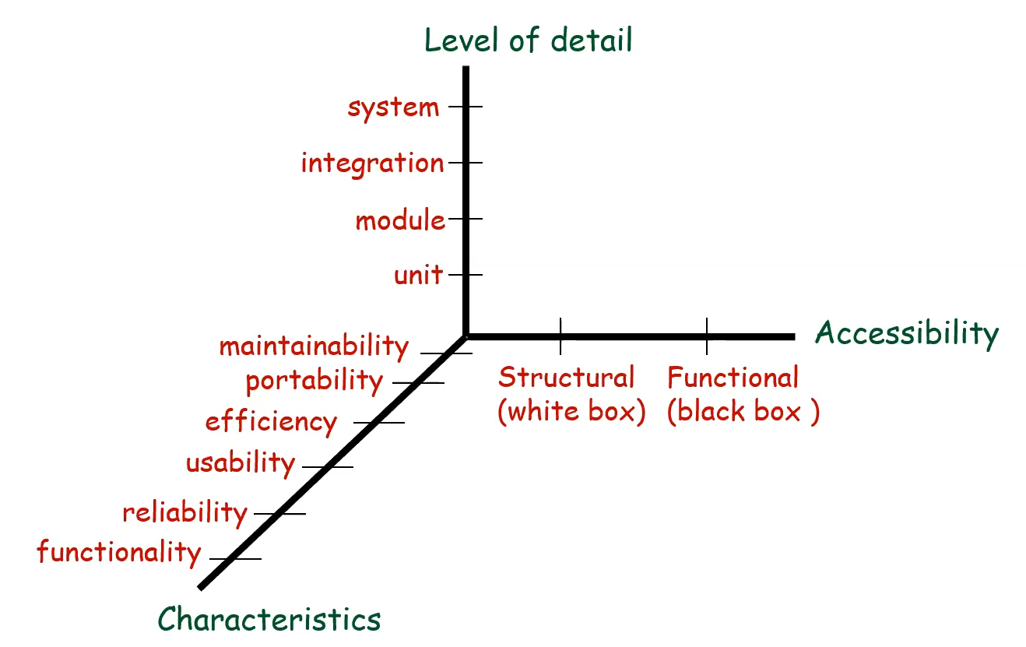
- Other dimensions: phases in development, goal, tester
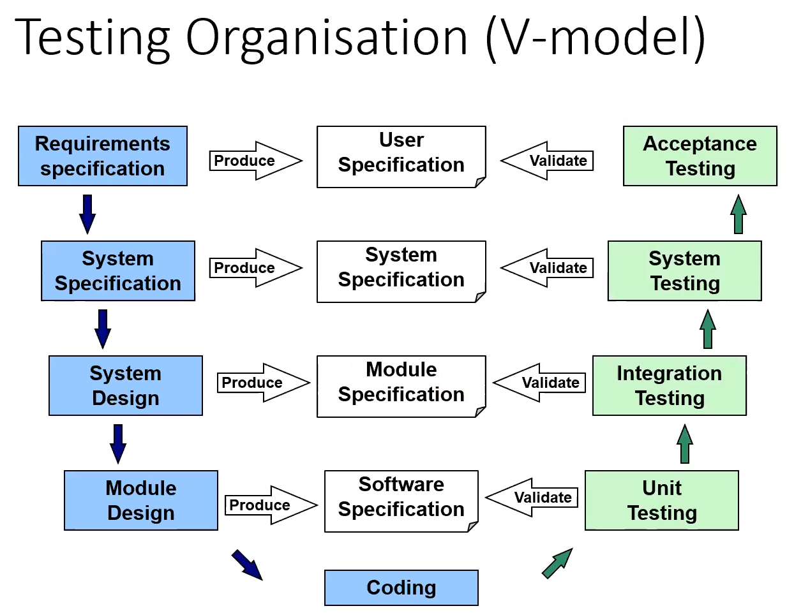

Software Testing – Automation
- Testability
  - Difficulty of establishing test criteria
  - How tests perform to meet those criteria
- Software Observability
  - Difficulty of observing I/O
- Software Controllability
  - Difficulty of providing the needed inputs (values, operations, behaviours)

Unit Testing
- Testing individual modules (methods/functions and classes)
- Based on info about the structure of a code fragment
- Objective – test that the unit performs the function it’s designed for
- Can be designed before coding begins or just after the source code is generated
  - Test-driven development (Red-green refactoring)
    - Write a new test
    - Run all tests (newly added one should fail)
    - Write the implementation code to make the test pass (KISS – Keep It Simple, Stupid)
    - Run all tests (tests should now pass)
    - Refactor (make improvements, naming, DRY)
    - Repeat
- Writing:
  - A good test is:
    - atomic
      - test exactly 1 piece of code, does not depend on any other tests, can be run repeatedly and/or concurrently
    - trustworthy
      - should run every time on every machine
    - maintainable
      - test code avoids repetition, magic numbers, etc
    - readable
      - code should make sense; names should describe what they are testing
  - 1. Set up predictable context
  - 2. Run a method and check that the result meets spec
    - Return value correct?
    - Expected exception thrown?
    - Correct side effects detected?
- JUnit
  - Widely used, over 30% of Java projects on GitHub use it
  - Basic idea:
    - For a given class (Foo), create another class (FooTest) to test it, containing various test case methods to run
    - Each method looks for particular results and passes/fails
  - Test Classes
    - A collection of test methods
    - Methods to set up the program state – test cases
  - Terminology
    - Test Fixture – a fixed state of a set of objects used as a baseline for running tests
      - Ensures that there is a well-known and fixed environment in which tests are run so that results are repeatable
      - Ex: when testing code that updates an employee record, you need an employee record to test it on
      - Fixtures can run before/after every test, or one-time fixtures can run before and after only once for all test methods in a class
        - Class-level fixtures: @BeforeClass and @AfterClass
        - Method-level fixtures: @Before and @After
  - Architecture
    - 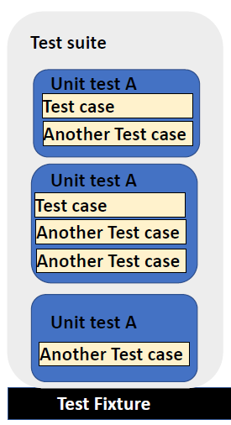 -> Test Runner
    - Test runner – a program that runs the tests and reports the results
    - Test case – tests the response of a single method to a particular set of inputs (@test) – a single unit test case
    - Test fixtures – a set of preconditions (i.e., state) needed to run a test
    - Test suite – a collection of test cases
- Benefits:
  - Find problems early in the dev cycle
  - Support refactoring and other code changes
  - Potentially simplify integration testing
  - Can provide a design document for the class
- Limitations:
  - Cannot catch every error – cannot cover every possible exe path
  - Cannot catch integration/system-level errors
  - Complexity of setting up realistic tests creating initial conditions
  - Tests could be buggy themselves
  - Cannot easily test problem that use randomness/multiple threads

JUnit Usage
- 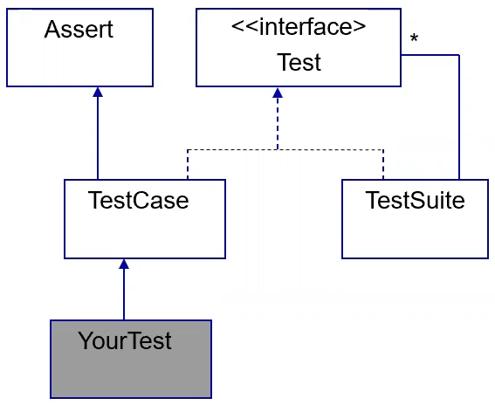
- Subclass TestCase
- Create Test methods
  - public void testXXX()
  - assertions per method
- Implement main to run from command-line, but not necessary
- Optionally, add setUp/teardown methods if any shared data is needed in tests
- Naming conventions
  - Widely used:
    - Add suffix “Test” to the name of test classes
    - Create in new package “test”
  - Name should explain what the test does
    - (“If you use good names, you don’t need to read the code”)
    - One possible convention: use “should” in the method name (“addShouldThrowExceptionOnNull”)
- Defining: use annotations
  - @Test: identifies a method as a test method
    - @Test (expected = Exception.class) – fails unless the given exception is thrown
    - @Test (timeout = 100) – fails if it takes more than 100 ms
      - Pervasive timeouts – almost every test should have a timeout to avoid infinite loops, good to set to a default
  - @BeforeEach: executed before each test is run (sets up fixtures)
  - @AfterEach: executed after each test is completed (deletes fixtures)
  - @BeforeAll: executes once before all tests in the file are run (e.g., connect to database)
  - @AfterAll: executed once after all tests in the file are run
  - @Ignore: indicates that the given test should be ignored
    - @Ignore(“Reason”) gives explanation (good practice)
- Writing Body (using Asserts)
  - Asserts – checks the actual result against expected result
  - Optional (but strongly recommended): specify the string to display if they do not match
  - Methods:
    - assertTrue
    - assertFalse
    - assertEquals
    - assertSame (==)
    - assertNotSame (!=)
    - assertNull
    - assertNotNull
    - fail() – causes test to fail
    - Each method can be passed a string to display if it fails
    - All in org.junit.Assert
  - How many assertions per test?
    - Depends:
      - Each test case should only potentially fail for one reason
      - But that reason could potentially involve multiple asserts
- Advanced:
  - Using matchers
    - assertThat(actual, is(equalTo(expected)));
    - is(), equalTo(), not(), containsString(), anyOf()
- Good practice:
  - Expected values at the left
  - Use messages explaining what is being checked for better failure output
  - Use expected answer objects (with toString and equals())
  - Use proper naming for test cases
  - Use timeout for all
Testing Tips:
- Don’t test every possible input, parameter value, etc (too long) – use limited set of tests likely to expose bugs
- Do boundary cases
  - Positive, zero, negative
  - Right at the edge of an array or collection’s size
- Do empty, error cases
  - 0, -1, null, empty list/array
- Test behaviour in combination
  - Try add() and then remove()
  - Make multiple calls (maybe ‘size’ fails the second time only)
- Trustworthy tests
  - Test 1 thing at a time per test method
    - 10 small tests > 1 test 10x as large
  - Tests should avoid logic
    - Minimise if/else, loops, switch
    - Avoid try/catch
      - If it’s supposed to throw, use expected=; if not, let JUnit catch it
- Test case “smells” (bad things to avoid):
  - Constrained test order: Test A must run before Test B (usually a misguided attempt to test order/flow)
  - Tests call each other (calling a shared helper class is ok)
  - Mutable shared state: Tests A/B both use a shared object (If A breaks it, cascades)

Summary
- Tests need failure atomicity (ability to know exactly what failed
  - Each test should have a clear, long, descriptive name
  - Assertions should always have clear messages to know what failed
  - Write many small tests, not 1 big test
    - Each test should have roughly just 1 assertion at its end
- Always use a timeout parameter to every test
- Test for expected errors/exceptions
- Choose a descriptive assert method, not always assertTrue
- Choose representative test cases from equivalent input classes
- Avoid complex logic if possible
- Use @Before to reduce redundancy between tests

Lecture 15: White-Box, Control Flow Testing

Control Flow Graphs
- A graphical representation of a program’s control structure
- Consist of nodes:
  - Decision points – the control can diverge (e.g., if statement)
  - Junction points – the control flow can merge (e.g., endif/end of for loop)
  - Process blocks – sequence of program statements uninterrupted by decisions/junctions
    - A process has 1 entry and 1 exit
- Multiple entry points
- Path – a sequence of consecutive nodes
- Complete testing:
- Cover every path from entry to exit
- Cover every statement at least once
- Cover every branch at least once
  - A implies B and C (but impractical)
  - B != C

White-Box Testing
- Fundamental Assumptions:
  - Executing a faulty statement is a necessary condition for revealing a fault
- Characteristics:
  - Based on program code
    - Can be measured objectively
    - Can be measured automatically
  - Can be used to compare test suites
  - Allows for covering the coded behaviour in software
- Limitations, can’t test:
  - Long time to check memory leaks
  - which portion of if condition is evaluated
  - what path the program took to achieve the end result
  - if there’s any dead/unused/unnecessary code
  - what the potential breaking points in code are
  - if code is compliant to best practices
- From Program Structure to Test Cases:
  - Select Test Data
  - Different Techniques:
    - Control flow
      - White-box approach
      - Based on structural strategy
      - Common in initial development cycles
      - Can identify bad software practices
      - Requires access to the source code
      - Coverage is the key criterion to define test requirements, specifications and cases
    - Data flow
    - Fault-based
- Coverage
  - Test coverage attempts to address questions about when to stop testing, or the amount of testing that is enough for a given program
    - Ideal testing is to explore exhaustively the entire test domain, which in general (and in practice) is impossible
  - Criteria
    - Defined in terms of test requirements
      - The elements/entities in the code that we need to exercise to satisfy the criteria
    - Results in a set of test specifications
      - Descriptions/specifications of the test required to satisfy the test requirement
    - Outcome is a set of test cases – instantiations of the test specifications
    - Even if everything is covered, not a guarantee all bugs will be found
    - Types:
      - Statement – every statement is covered at least 1x
        - Test requirements – All the statements in the program
        - Coverage Measure – no. of executed test statements (by a test case) divided by total no. of statements
        - Most used in the industry
        - Typical coverage target is 80-90%
      - Branch – every branch is covered
        - Test Requirements – All branches in the program
        - Coverage Measure – no. of executed branches (by a test case) divided by total no. of branches
      - Condition – every tester-made condition is represented as T and F
        - Test Requirements – Individual conditions in the program
        - Coverage Measure – no. of conditions that are both T and F divided by total no. of conditions
        - Condition Coverage is separate, doesn’t subsume anything
      - Branch and Condition
        - Test Requirements – all branches and individual conditions in the program
        - Coverage Measure – Computed considering both coverage measures
        - Subsumes all previous coverages
      - Modified Condition/Decision
        - Very important criterion as it is often required for safety-critical applications
        - Approach: Extend branch and decision coverage with requirement that each condition should affect the decision outcome independently
        - Identifying important combinations: Combinations in which a single condition independently affects the outcome of the overall predicate
        - Subsumes all previous coverages with fewer test cases
      - Path
        - Subsumes Branch
      - Data Flow
        - Separate
      - Mutation
        - Separate
      - Multiple Condition
        - Subsumes all previous
    - Test Criteria Subsumption
      - One test criterion subsumes another criterion when all the test suites that satisfy that criterion will also satisfy the other
      - If a test suite achieves 100% branch coverage, the same test suite will also achieve (necessarily) 100% statement coverage
- Control Flow Testing
  - Uses statement and branch testing
  - Even with 100% branch and statement coverage, not a guarantee all bugs will be found
Summary
- About 65% of all bugs can be caught in unit testing
- Unit testing is dominated by control flow testing methods
- Statement and branch testing dominates control flow testing
- Studies show that control flow testing catches 50% of all bugs caught during unit testing
  - About 33% of all bugs

Week 9

Lecture 16: Black-Box, Combinatorial Testing

Combinatorial testing – a type of black box testing
Functional (Black-Box) Testing
- Advantages:
  - Focus on the domain
  - No need for the code – Makes early test design possible
  - Catches logic effects
  - Applicable at all granularity levels (even high)

Functional Specification
- Statement of the application functional and operational requirements
- Serves as a contract between the developer and the customer for whom the system is being developed
- Format:
  - Name, synopsis (usage), description
Test Data Selection
- Addresses the problem of identifying relevant inputs for a software feature
  - From Input Domain (black-box testing) to Software to Output Domain (test cases)
- Exhaustive Testing
  - Brute force trying everything
  - Hard because it’s too long
    - Sometimes, impossibly long
  - Quantity doesn’t matter if there’s no quality
  - Impractical even for small functions
- Random Testing
  - Use a RNG to generate test cases
  - Derive estimates for the reliability of the software using some probabilistic analysis
  - Coverage is a problem:
    - Sometimes, important cases are very unlikely (like 2 integers being the same)
    - Naïve random testing will not be effective
  - Impractical
- Partition Testing
  - Non-naïve random testing approach
  - Conceptually, creates a grid of input domain for a software programs, squares being individual inputs
  - Failing inputs are generally sparse (looking for bugs is like finding needles in a haystack)
    - But they tend to be dense in some parts of the domain
    - Pareto’s Law – “Approximately 80% of defects come from 20% of modules”
  - Input domain tends to be naturally split into partitions
    - Each partition is a block that defines a set of equivalent subdomains
      - Ex: calendar
        - A function that takes any month of the year and returns no. of days
        - Subdomains:
          - Month less than 1
          - Month between 1-12
          - Month greater than 12
        - Month Value characteristics used to define equivalent subdomains
      - Ex: bus ticketing price
        - Children <6 years go free. Young people pay 2.50, Adults 5 and Senior Citizens pay 1
        - Classes:
          - Age 0-5: price 0
          - Age 6-18: price 2.50
          - Age 19-64: price 5
          - Age 65+: price 1
        - Age values characteristic used to define equivalent classes
    - A partition is usually based on some characteristic of the program and the program’s inputs
      - Ex:
        - null, not null
        - order of files (sorted, inverse sorted, arbitrary)
        - min. separation distance of aircraft (10 km, 20 km)
    - A partition must satisfy 2 properties:
      - The partition must cover the entire domain (completeness)
      - The blocks must not overlap (disjoint)
  - Input Domain Model
    - Approaches:
      - Interface-based input domain modelling
        - Develops characteristics directly from input parameters to the program under test
        - Typically, each input parameter is considered in isolation
        - Advantage: Relatively easy to identify characteristics
        - Disadvantage: Not all info is reflected in the interface, an testing some functionality may require parameters in combination
      - Functionality-based input domain modelling
        - Develops characteristics from a functional/behavioural view of the program under test
  - Choosing blocks and values:
    - Dilemma:
      - More blocks will result in more tests, requiring more resources but possibly finding more faults
      - Fewer blocks will result in fewer tests, saving resources but possibly reducing test effectiveness
    - Strategies:
      - Valid values: Include at least 1 group of valid values
      - Invalid values: Include at least 1 group of invalid values
      - Boundaries: Values at or close to boundaries often cause problems
        - Select input at boundaries
        - Boundary testing (selection of boundary inputs) is complementary to partition testing
        - Ex: partition into size of string, choose input as -1, 0, 1, MAXINT
      - Missing partitions: Check that the union of all blocks of a characteristic completely covers the input space of that characteristic
      - Overlapping partitions: Check that no value belongs to more than 1 block

A Systematic Functional Testing Approach
- From Functional Specification to Test Cases
  - Functional Specification
  - 1. Identify Independently Testable Features
    - Ex: getSum(int a, int b) has 1, word processor has several (cut, paste, fonts, italics)
  - 2. Identify Relevant Inputs (for each feature)
    - Using Partition and Boundary Value Testing
  - 3. Derive Test Cases Specifications
    - Test Case Specification – defines how values of relevant inputs should be put together when testing the system
    - Combinatorial approach – combining types of possible inputs
      - Combinatorial explosion – blindly taking the cross product of all inputs
      - Avoid meaningless combinations
  - 4. Generate Test Cases
    - Mechanical process
The Category-Partition Method
- Ostrand & Balcer, CACM, June 1988
- Specification to Test Cases in 6 steps:
- Identify independently testable features
  - From systematic approach
- Identify Categories
  - Category – characteristic of each input element
    - ex: str (length, content), size (value)
- Partition categories into choices
  - cases of characteristic (ranges in value, spaces, etc)
- Identify constraints among choices
  - To eliminate meaningless combinations
  - To reduce the number of test cases
  - 3 types of constraint properties:
    - PROPERTY … IF
      - Assign property to some case
      - Only include other cases if property true/not true (like emptyString)
    - ERROR
      - Mark cases as invalid (like string length being less than 0)
      - Combinations with invalid cases will automatically be invalid
    - SINGLE
      - Mark a case that doesn’t need to be repeated – once tested is enough (like MAXINT for string length)
- Produce/evaluate test case specification
  - Can be completely automated
  - Result is a set of test frames (specification of a test)
- Generate test case from test case specifications
  - Involves simple instantiation of test frames
  - Final Result: Set of concrete test cases

Exam Format
(weird inconsistency with MEF’s email)

Types of questions:
- MCQ
  - Wrong answer penalised by 25% of the mark of the question
- Short answers
  - Fill-in
- Essay/refactoring
  - The refactoring can be as short as 1 word

